

By

Shivam Kumar





 To analyze the demand supply gap for Uber ,a transportation network company, for two services in a city as follows:

1. City to Airport Service 2.Airport to City Service

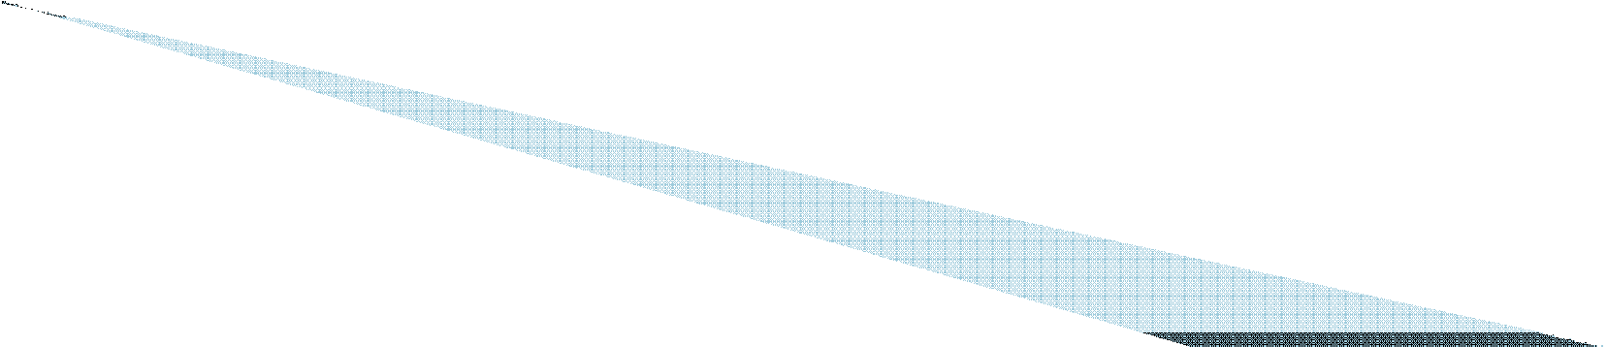



 Data is for 5 days from 11/07/2016 to 15/07/2016

 Six attributes associated with each request made by a customer:

* **Request id**: A unique identifier of the request
* **Time of request**: The date and time at which the customer made the trip request
* **Drop-off time**: The drop-off date and time, in case the trip was completed
* **Pick-up point**: The point from which the request was made
* **Driver id**: The unique identification number of the driver
* **Status of the request**: The final status of the trip, that can be either completed, cancelled by the driver or no cars available







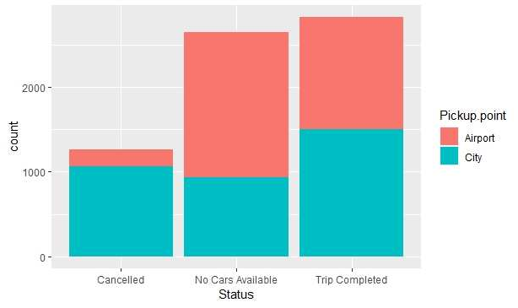

From the graph we can come to the following conclusions

* From City to Airport, Cancellation of trips status is higher where as from Airport to City ,No Cars Available status is higher
* Most problematic type of request is from Airport to City

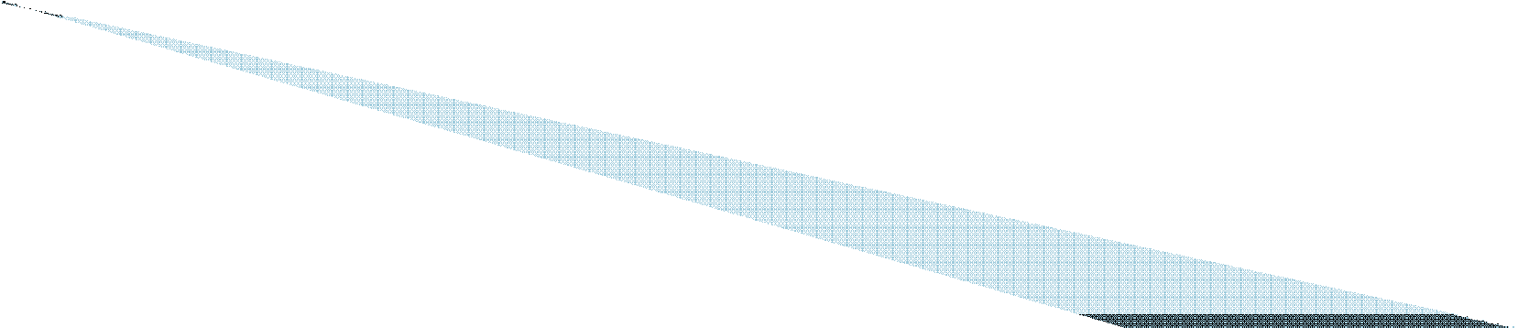



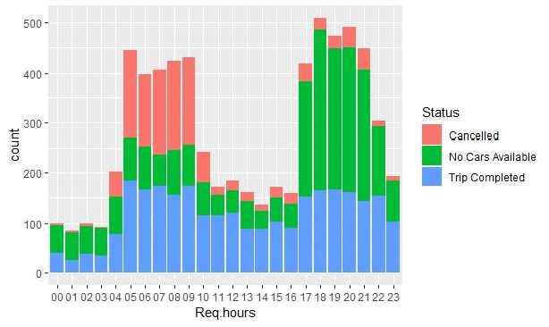

* + Maximum request of Cars are on Early Morning( 5 AM to 9AM) and on evenings from (5PM to 10PM )
  + On Mornings, Cancelled trips status is higher
  + On Evenings, No Cars Available status is higher





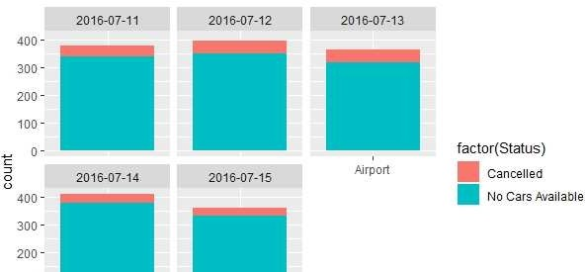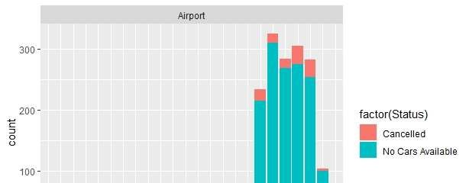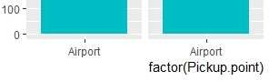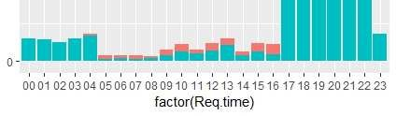

* From Airport to City ,No Cars Available Status is Higher
* Frequency of Services not getting completed are higher at evening hours (5PM to 10PM)

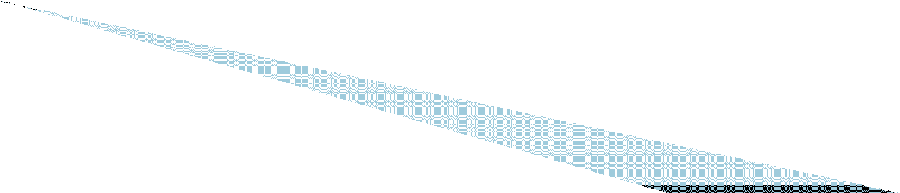



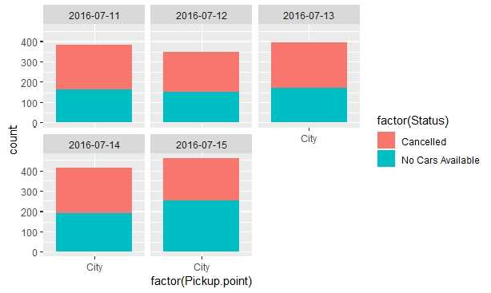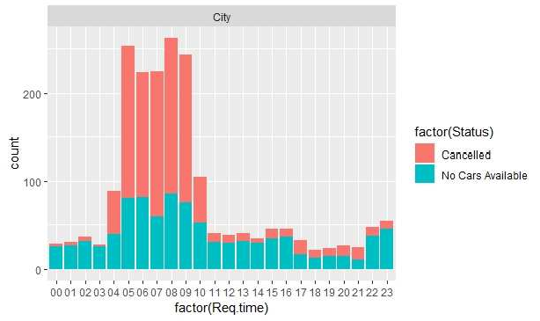

* + From City to Airport ,Cancellation Status is Higher
  + Frequency of Services not getting completed are higher at early morning hours (5AM to 9AM)





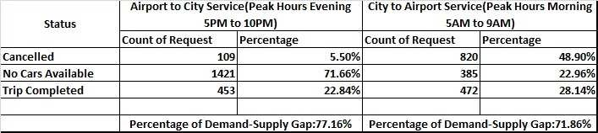

For Airport to City Service, the non availability of cars is at 71.66% during the peak hours of 5PM to 10PM. These may be due to the following reasons

* Heavy traffic in City during these hours occupy the drivers within the city as they will get more calls from the city. More revenue generation will be from city than to take a single trip to airport
* As most of the international flights are scheduled to departure after midnight, more cars will come to airport after 10PM

Cont…

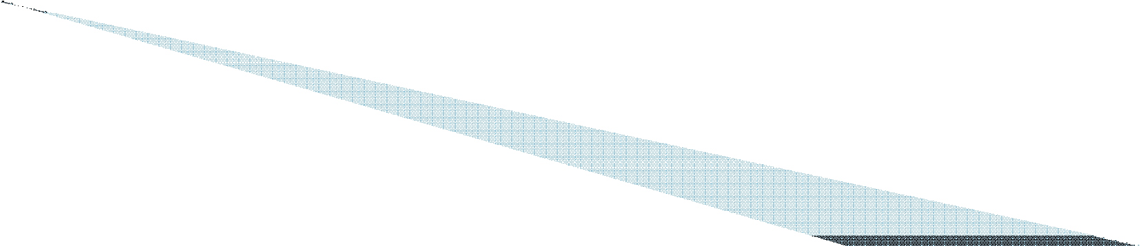



For Airport to City Service, the cancellation of cars is at 48.90 % during the morning peak hours of 5AM to 9AM. These may be due to the following reasons

* Most of the traffic in city will be in these period. So more monetary gain will be from the services inside the city
* As the departure of most international flights are after midnight and less arrival during these period, drivers suspect more idle time at airport during this time which will reduce their revenue





1. For the issue of No cars available from airport to city during evening hours, following approach can be taken

* Special offers and incentives for drivers making the trip from Airport during these hours can be given, which will increase their interest in taking the trip
* Sharing of a taxi by many passengers can be encouraged, there by reducing the number of cars required at airport during these hours
* Prebooking for Airport to City Service can be encouraged so as to know the requirement at airport during these hours

1. For the issue of cancellation of cars from city to airport during morning hours,following approach can be taken

* Special offers and incentives for drivers making the trip to Airport during these hours can be given, which will increase their interest in taking the trip
* Increasing the rate during these hours to airport or by reducing the share of uber
* Sharing of a taxi by many passengers can be encouraged, there by reducing the number of cars required to airport during these hours

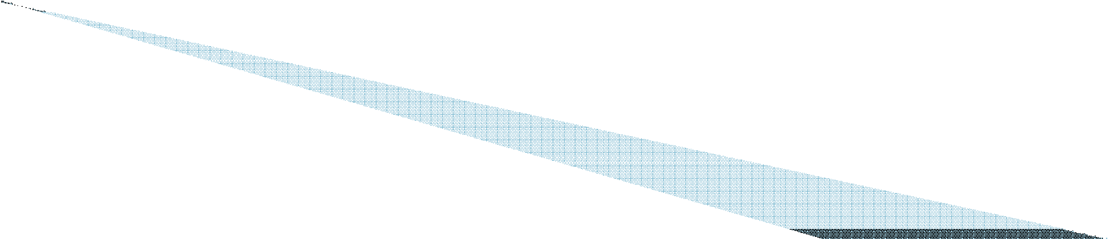

**THANK YOU**